1.Which customer(male/female) generate highest revenue?
Ans:
select gender ,sum(purchase_amount) as revenue
from customer
group by gender;
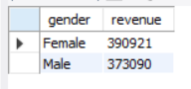

2.Which product category earn more sale or revenue?
Ans:
select category,sum(purchase_amount) as revenue ,count(*)as total_sale
from customer
group by category
order by revenue desc;
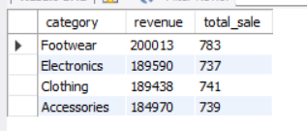

3.Which season earn highest revenue?
Ans:
select season,sum(purchase_amount)as revenue,count(*)as total_sale
from customer
group by season
order by revenue desc;
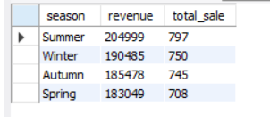
4.Which payment method earn highest revenue?
Ans:
select payment_method,sum(purchase_amount)as revenue,count(*)as total_sale
from customer
group by payment_method
order by revenue desc;
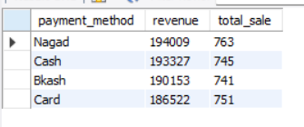

5.Which age group earn more revenue?
Ans:
select age_group,sum(purchase_amount)as revenue,count(*)as total_sale
from customer
group by age_group
order by revenue desc;
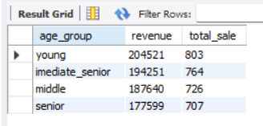

6.If we use discount is customers purchase amount increase?
Ans:
select discount_applied,sum(purchase_amount)as revenue,count(*)as total_sale
from customer
group by discount_applied
order by total_sale desc;


